Outline:

- Unit Root Test:
  - Graphical (Linear Term ACF, PACF)
  - Formal (ADF, Phillips/Peronas, KPSS)
- ARMA/GARCH
- Normality Tests (Using simple return):
  - Graphical (QQ-plots, Histogram)
  - Formal (Jarque–Bera test, Kolmogorov–Smirnov test)
- Fractional Integrated Tests:
  - Graphical (Aggregated Variance, Periodogram(log), ACF(log-log, Regular), R/S)
  - Formal (GPH, Sperio, Whittle)
    - d-parameter estimation
    - d-parameter confidence interval using Monte Carlo Simulation. (Random normal & Resample)
    - Repeat and test whether new d = 0
- Model Fitting (GARCH, ARMA)
- Model Checking (Forecasting error)
- Simulation

Results:

- Unit Root Tests
  - Tests done on original data
  - Graphical
    - Non-linear Trend in ACF

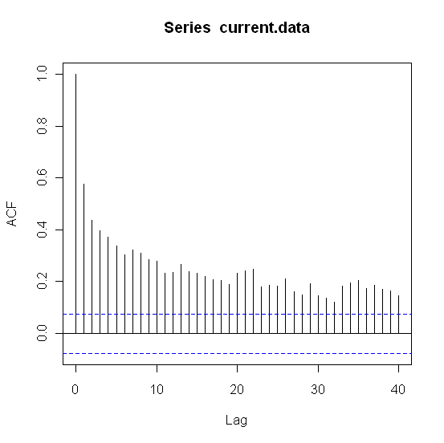

    - PACF Plot (to find lag)
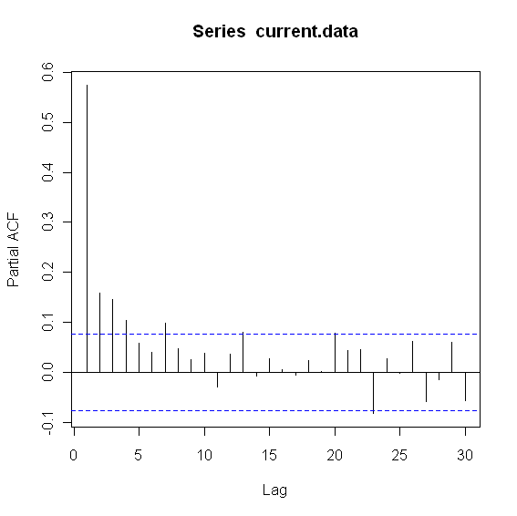
  - Formal
    - ADF w/ lag = 4 (H_{o}: y_{t} ~ I(1), unit root stationary, H_{a}: y_{t} ~ I(0), non unit root stationary)
    - ADF – CT (regression w/ constant (C) and trend (T))
      - Test Statistic = -6.6711
      - P-value = 0.01
    - Phillips – Perron (H_{o}: y_{t} ~ I(1), unit root stationary, H_{a}: y_{t} ~ I(0), non unit root stationary)
      - Test Statistic = -14.568
      - P-value = 0.01
      - Truncation lag parameter = 6
    - KPSS (H_{o}: y_{t} ~ I(0), non unit root stationary, H_{a}: y_{t} ~ I(1), unit root stationary)
      - Short truncation lag
        - KPSS Trend = 0.2972
        - P-value = 0.01
        - Truncation lag parameter = 5
      - Long truncation lag
        - KPSS Trend = 0.1437
        - P-value = 0.0542
        - Truncation lag parameter = 18

- ARMA / GARCH
  - ARMA Model
    - EACF Plot to determine ARMA order (also used ACF/PACF)
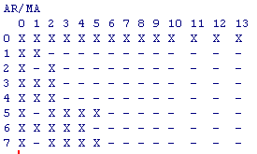

    - ARMA(2,1)

Call:
arima(x = current.data, order = c(2, 0, 1))

Coefficients:
ar1 ar2 ma1 intercept
1.2762 -0.3002 -0.8531 11.4878
s.e. 0.0715 0.0610 0.0537 0.1610

sigma^2 estimated as 0.4878: log likelihood = -703.14, aic = 1416.29

    - Box-Ljung Tests
      - Residuals of Nile Data
Q(12) P-value df
6.38 0.701 9

      - Residuals^2 of Nile Data
Q(12) P-value df
23.66 0.023 2

  - GARCH Model
    - GARCH(1,1) with ARMA(2,1)

Maximum Likelihood Estimation (Std.Errors based on Second derivatives)
Coefficient Std.Error t-value t-prob
Cst(M) 11.524248 0.11912 96.75 0.0000
AR(1) 1.000000 1.2918 0.7741 0.4391
AR(2) -0.106731 0.82108 -0.1300 0.8966
MA(1) -0.543666 1.4092 -0.3858 0.6998
Cst(V) 0.184434 0.13202 1.397 0.1629
ARCH(Alpha1) 0.142997 0.060934 2.347 0.0192
GARCH(Beta1) 0.488994 0.28470 1.718 0.0863

    - Box-Ljung Tests
      - Standardized Residuals of Nile Data
Q(12) P-value df
9.73 0.373 9

      - Standardized Residuals^2 of Nile Data
Q(12) P-value df
5.76 0.835 10
- Normality Tests
  - Skewness

Ŝ(r) = 0.525375
H₀: Ŝ(r) = 0
H_{A}: Ŝ(r) ≠ 0
t-statistic = Ŝ(r) /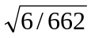= 5.52
  - Kurtosis

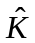(r) = 2.449481
H₀: E.(r) = 0
H_{A}: E.(r) ≠ 0
t-statistic = (r) /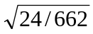= 12.86
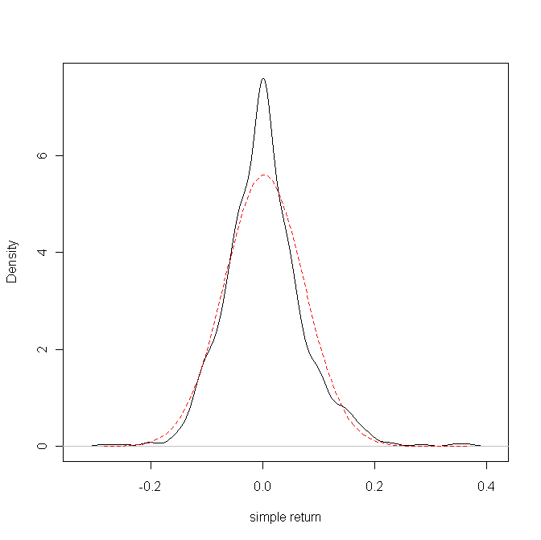
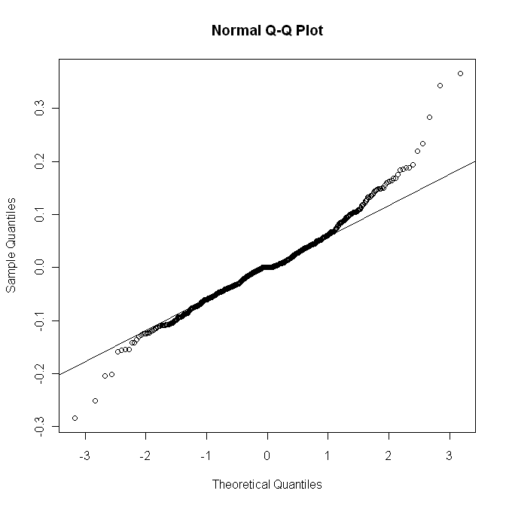
Nile simple returns:

Box-Cox test for the Nile River data suggests that a log transformation (power of 0)of the data would result in a normality distribution.

Box-Cox Power Transformation:

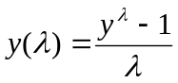 if 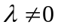 and 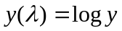 if 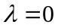

Box-Cox Transformation to Normality

Est.Power Std.Err. Wald(Power=0) Wald(Power=1)
-0.0676 0.4165 -0.1622 -2.5633

L.R. test, power = 0: 0.0263 df = 1 p = 0.8711
L.R. test, power = 1: 6.6113 df = 1 p = 0.0101

Normality tests for the original vs. log transformed Nile data

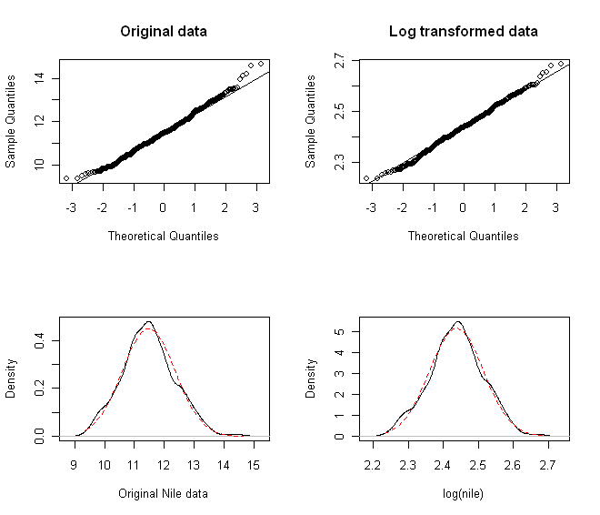

Original Nile data  One-sample Kolmogorov-Smirnov test  STATISTIC:  D: 1  P VALUE:  Alternative Two-Sided: < 2.2e-16  Alternative Less: < 2.2e-16  Alternative Greater: 1  Shapiro - Wilk Normality Test  STATISTIC:  W: 0.9933  P VALUE:  0.004614  Jarque - Bera Normalality Test  STATISTIC:  X-squared: 6.8061  P VALUE:  Asymptotic p Value: 0.03327  Anderson - Darling Normality Test  STATISTIC:  A: 0.9264  P VALUE:  0.01859  D'Agostino Normality Test  STATISTIC:  Chi2 | Omnibus: 6.9094  Z3 | Skewness: 2.5507  Z4 | Kurtosis: 0.6349  P VALUE:  Omnibus Test: 0.0316  Skewness Test: 0.01075  Kurtosis Test: 0.5255  Lilliefors (KS) Normality Test  STATISTIC:  D: 0.0439  P VALUE:  0.004084 | Log transformed Nile data  One-sample Kolmogorov-Smirnov test  STATISTIC:  D: 0.9873  P VALUE:  Alternative Two-Sided: < 2.2e-16  Alternative Less: < 2.2e-16  Alternative Greater: 0.9827  Shapiro - Wilk Normality Test  STATISTIC:  W: 0.9963  P VALUE:  0.1302  Jarque - Bera Normalality Test  STATISTIC:  X-squared: 0.1235  P VALUE:  Asymptotic p Value: 0.9401  Anderson - Darling Normality Test  STATISTIC:  A: 0.6247  P VALUE:  0.1034  D'Agostino Normality Test  STATISTIC:  Chi2 | Omnibus: 0.0616  Z3 | Skewness: 0.1621  Z4 | Kurtosis: -0.1879  P VALUE:  Omnibus Test: 0.9697  Skewness Test: 0.8713  Kurtosis Test: 0.851  Lilliefors (KS) Normality Test  STATISTIC:  D: 0.0371  P VALUE:  0.03039

Simulated N(0,1) Data, 662 Observations:
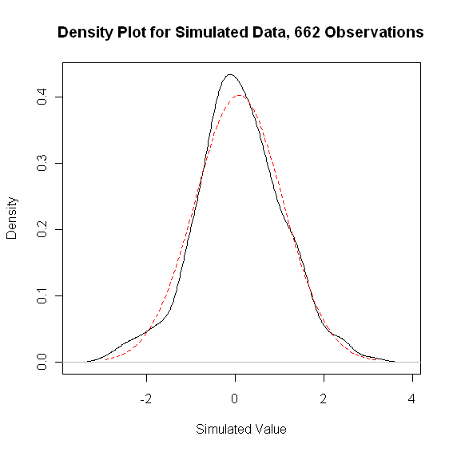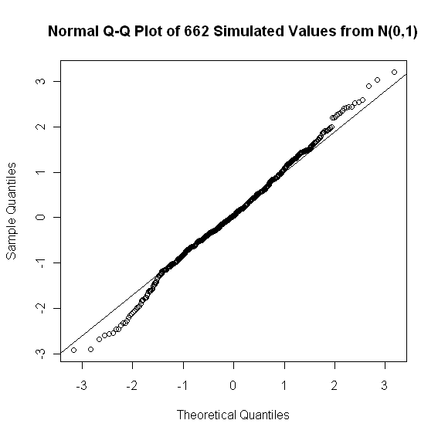

Simulated N(0,1) Data, 134 Observations:
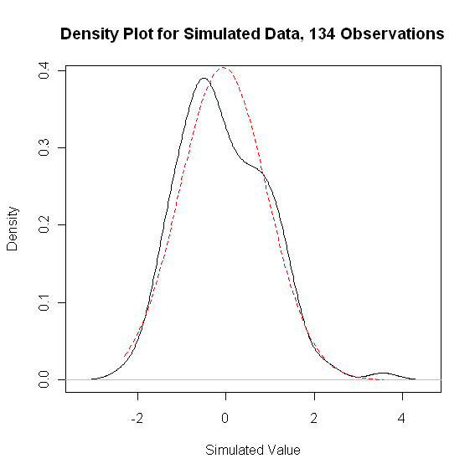
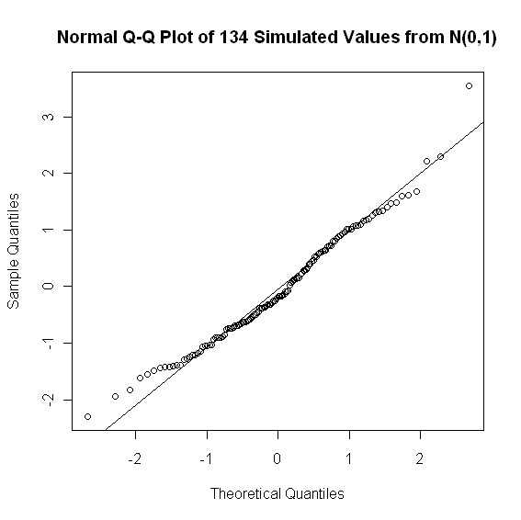

- Fractional Integrated Tests
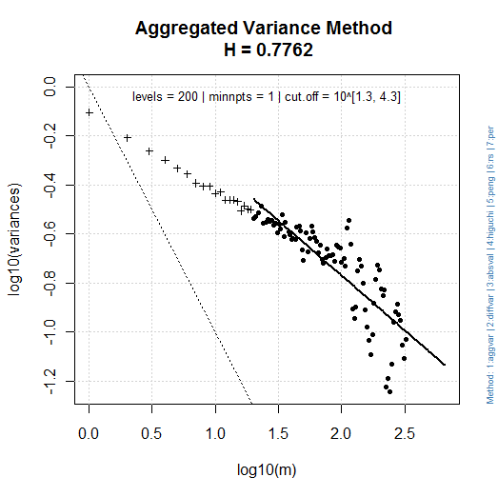 | 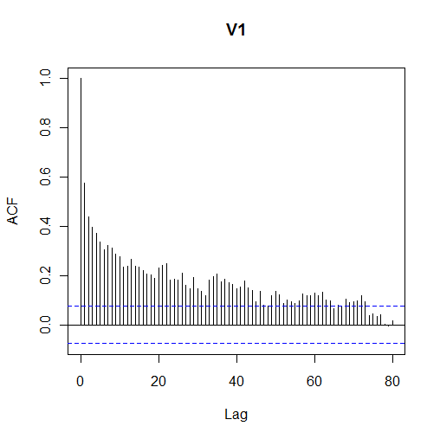
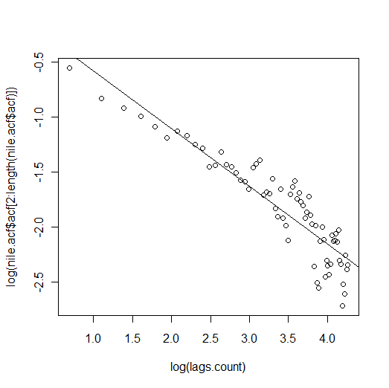 | 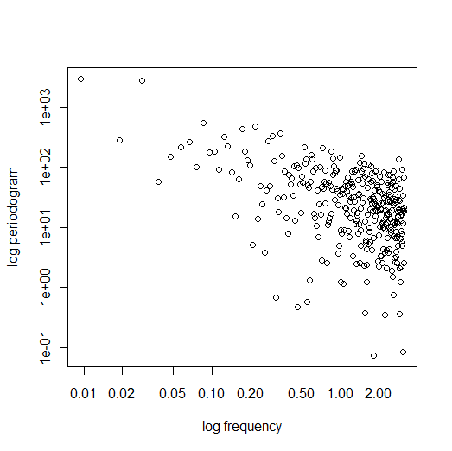
  - Graphical
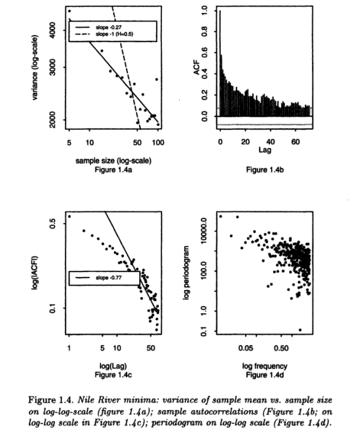
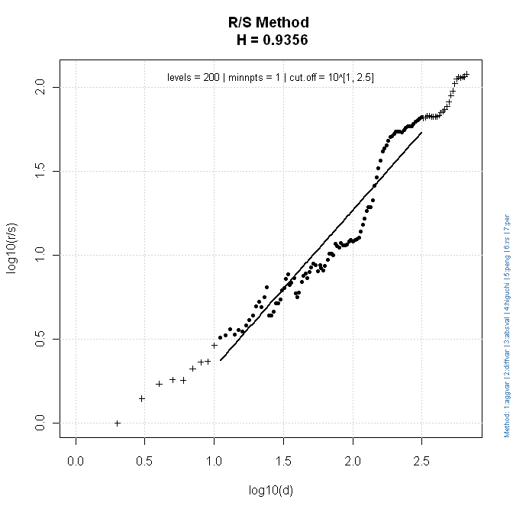

b) Whittle Fit:

1) FGN

Results: theta = 0.09854012 0.837425
H = 0.837425 => (d = 0.337425)
95%-CI for H : [ 0.7864071 , 0.888443 ]

2) FARMA

Results: theta = 0.0989124 0.8991992
H = 0.8991992 =>(d = 0.3991992)
95%-CI for H : [ 0.839536 , 0.9588624 ]

“d” Sperio estimate : 0.4427007

“d” fractionally diff. series : -0.006904546

Re-estimation of the H-parameter of the fractionally differenced series using “d” values estimated by “FGN” and “FARMA” whittle fits.

is the estimated d-parameter after fractionally differencing the data with GPH

H₀: = 0
H_{A}: ≠ 0

test statistic = / SE()
compare test statistic with empirical 95% quantile

1) FGN Whittle Fit (“d” = 0.337425)

Results: theta = 0.1580748 0.5559218
H = 0.5559218
95%-CI for H : [0.5076023 , 0.6042414]

2) FARMA Whittle Fit (“d” = 0.3991992)

Results: theta = 0.1589146 0.49875
H = 0.49875
95%-CI for H : [0.4390869 , 0.5584131]
- Simulation
  - Whittle-FARMA
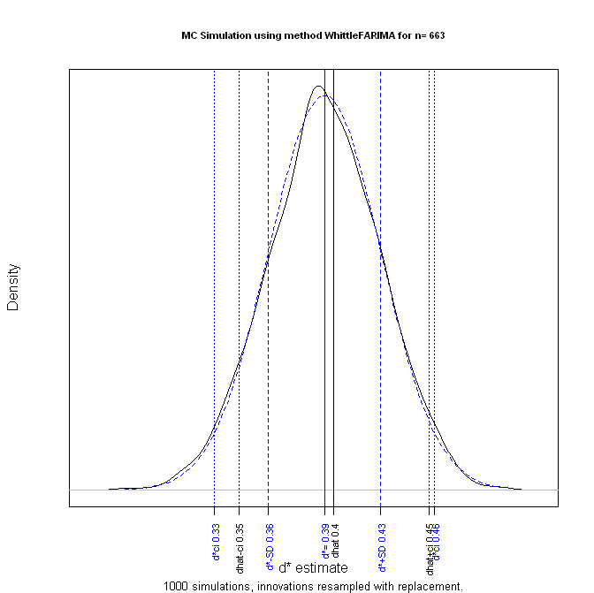 | 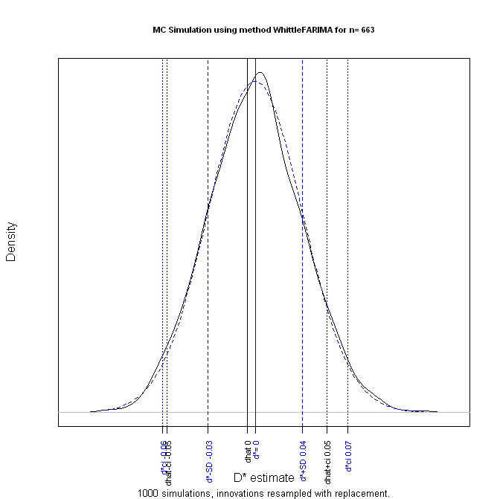

  - Sperio
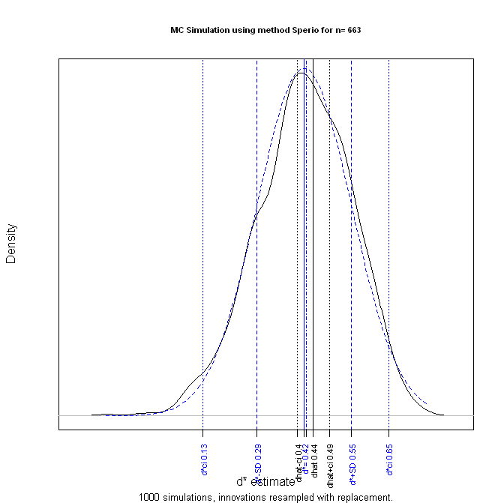 | 